**GCP Lec 1** :- Ss 5:12,

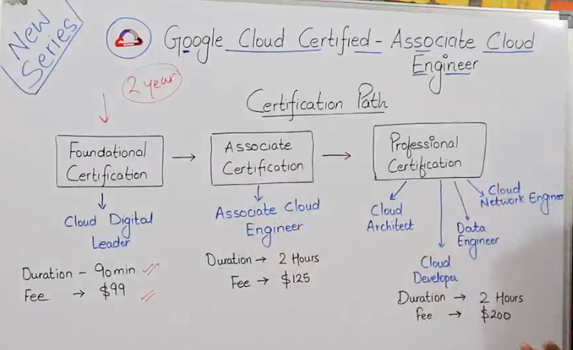

we can take retest after 14 days, then 60 days and then after 1year

Some things that will never change easily in any cloud technology whether AWS or GCP or Azure – Storage, VM, VPC/Subnet, IAM etc.

Lec 2 :-

The need for cloud computing : Earlier it was very costly to initially setup an infrastructure for an application development. Server, Network, Router, Firewall, Storage cost, Manpower cost (Administrator team, Network team etc) and Maintenance costs need to be incurred. When demand of the application increased then we had to upscale the infrastructure but later if we had to downscale then it lead to wastage or unutilisation of resources. One more issue was that even after spending huge on all the above costs still the application had to face downtime many times due to multiple reasons and it used to take a notable time to resolve the issue. This resulted into a huge loss to the businesses.  Ss 12:30

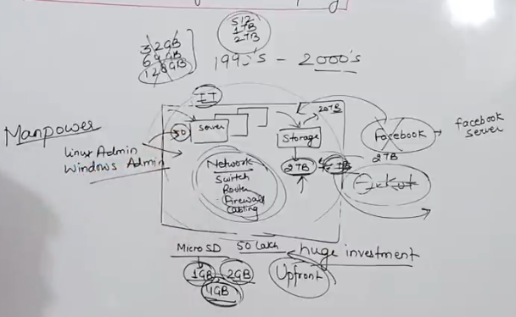

Realtime example of a working Machine and Configurations of a Computer System, Ss 20:38

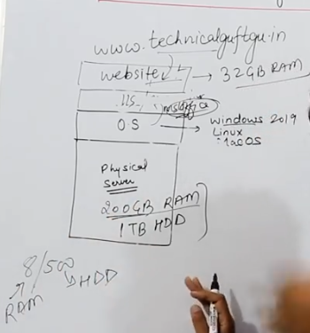

Ss 37:07

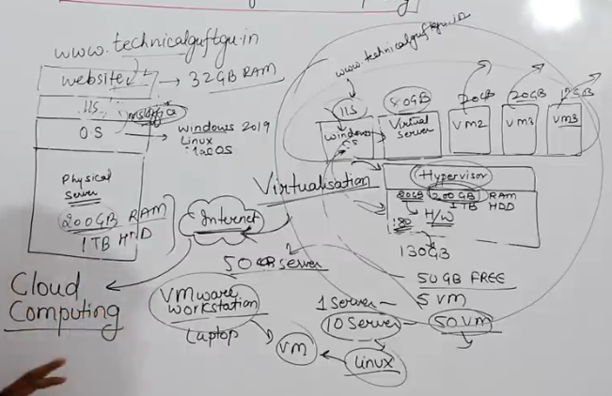

Suppose if we have 200GB Ram and 1 TB Hard Disk configured system (or server) but we just need 32GB Ram to run our Application (or website), then on top of our hardware, instead of directly installing the OS if we first install the Hypervisor then we can can break the physical server logically into multiple virtual servers. Thus, by using the Hypervisor, now we can start using the big physical servers as smaller virtual servers by dividing them based upon our requirement.

This will lead to huge reduction in Capex and Opex. These are the benefits of Virtualization.

The evolution to Cloud was step by step. Firstly Virtualization came into existence. Then due to some of it's limitations Cloud came into existence. Then due to some of it's limitations Containerization and Microservices came into existence.

Now in Virtualization, if we need to update/install any software in our server, we require the hardware access of the machine. So, to access hardware, the whole system including the hardware, the Hypervisor, the virtual servers etc was virtualized and made available over the internet using Cloud. So, with Cloud we can virtually access any of our machines (and their resources) remotely, while the machine may be physically present in any part of the world, using the internet.

Official Definition of Cloud Ss 38:53

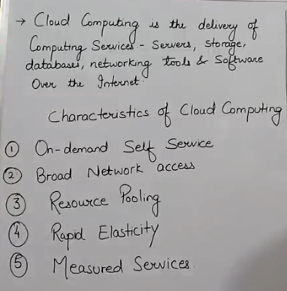

Characteristics of Cloud Ss 47:35 & 47:45

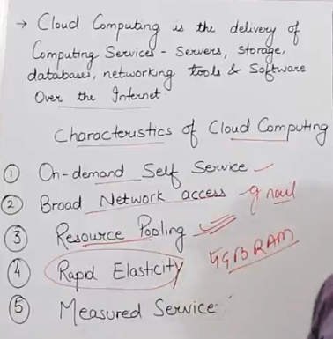 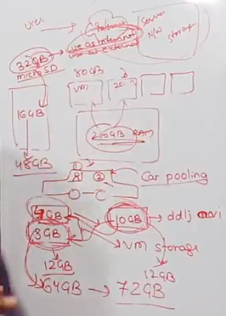

Cloud also provide resource addition (adding multiple resources to make a single resource) along with resource pooling (dividing single resource to multiple resources)

Cloud provided feature of pay-as-you-go, due to which running an application has become cheaper. This feature alone has lead to huge startup culture in India (and everywhere else).

Lec 3 :- Iaas vs Paas vs Saas explained Ss at 14:32

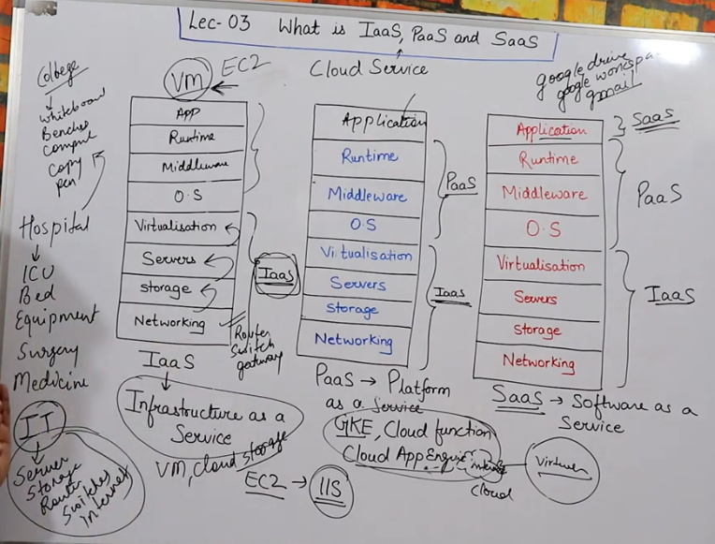

Types of Cloud, Ss 18:18 & Ss 22:50

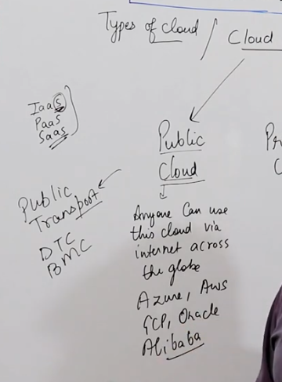 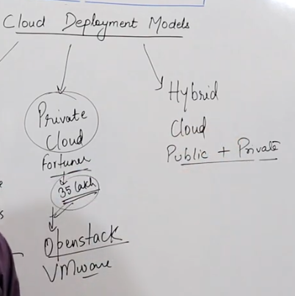

*Public cloud is also very secure just like private cloud

Private cloud - Both public and private cloud are secure but private cloud is more secure than public cloud

Private cloud has huge upfront cost i.e. Capex

Hybrid cloud - using both public and private cloud. Many companies use some services of public cloud and some services of private cloud.

Important data is kept in private cloud and normal data is kept in public cloud

Lec 4 :- Zones and Regions Ss 17:20

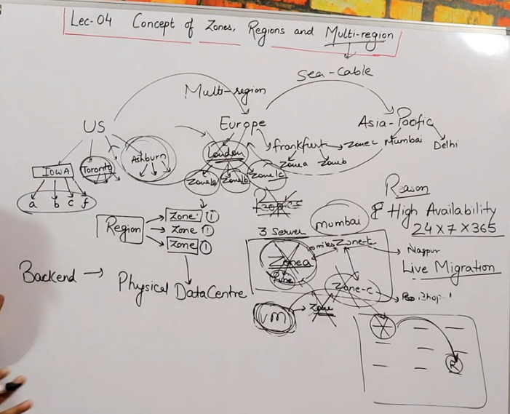

Ss 32:18 & Ss 39:58

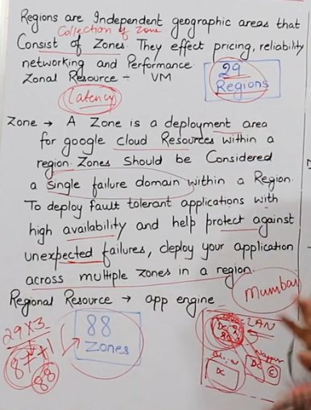 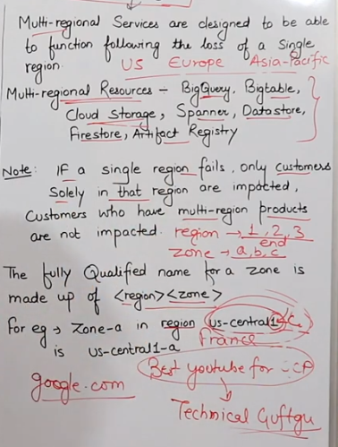

Region ends with 1,2,3 (numerics) and Zone ends with a, b, c (alphabets)

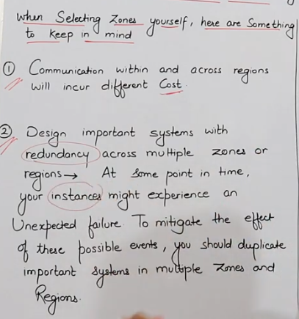 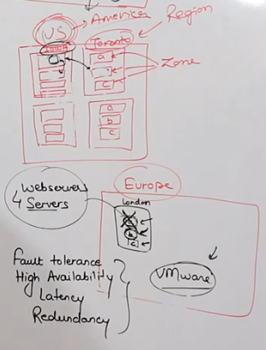

Ss 41:08 & Ss 45:58

Study TG VMware series

Lec 5 :- Resource Hierarchy Ss 16:03 & Ss 16:14

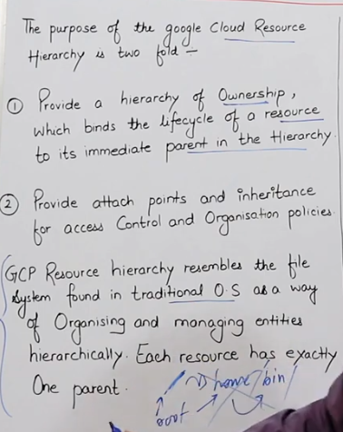 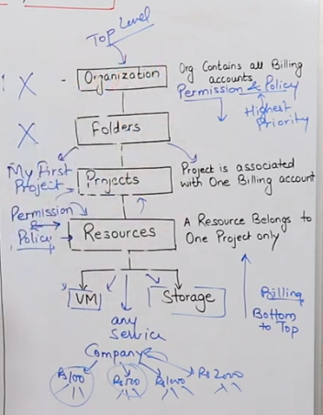

Ss 27:33

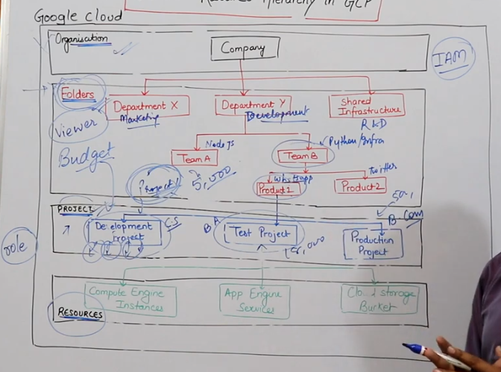

**Organization and Folders are available to you only if you have a Company account in GCP (eg. You have a company url)

If you have a Personal account in GCP, then Organization and Folders will not be visible to you and only Projects and Resources will be visible.

**Folders inside folder or nested folders is possible

Nested Projects is not possible

**Folders will get the details of all the billing processed for each of the projects.

**Also, budgeting or fixing budget i.e. defining a maximum limit of bill to be generated can be done for each project to minimize the expenses

**Each project has the control over the resources it is using.

Each project cannot access/control the resources of any other project i.e. each project is isolated.

**If let's say the Security Team needs access to the resources of each Project then it is also possible by providing permissions to it at the Folders level. (In case of Company account)

*In case of a Personal account, in the above case, the Security team with be provided access to the resources from inside each of the Project by defining certain permissions or policies also known as defining a Role.

Ss 33:36 & Ss 33:40

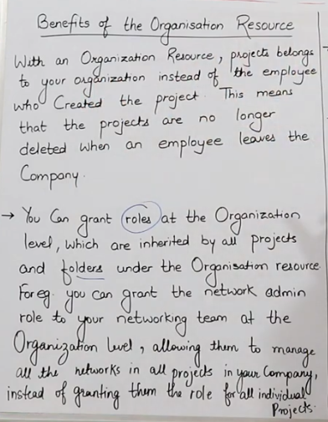 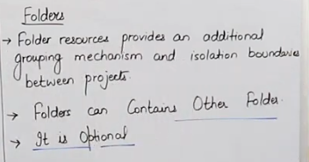

Ss 42:04 & Ss 47:29

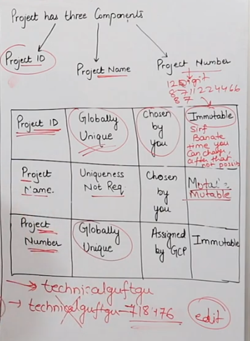 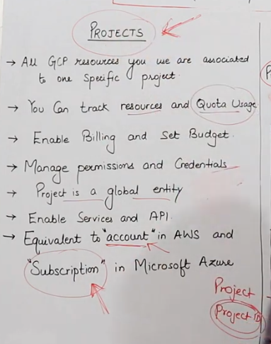

* A Project can be transferred from one folder to another by changing the IAM policies.

Lec 6 :-

Lec 7 :-

*Google cloud is the same cloud that google uses to run it's own services. It uses the same infrastructure that is provides under GCP that is already being used by its various Applications/Services like Gmail, YouTube, Google Drive etc. So, we get the same reliability in GCP.

*Also, Google uses most of the hardware at the backend which is being developed by their own team. Google uses its own hardware such as servers and storage. Google has its own R&D Team for it. And except the Amd and Intel processor and maybe some other things, maximum hardware is developed by google itself.

Ss 6:44 Types of Compute services in Google (server based and serverless) (In this lecture we only cover compute engine)

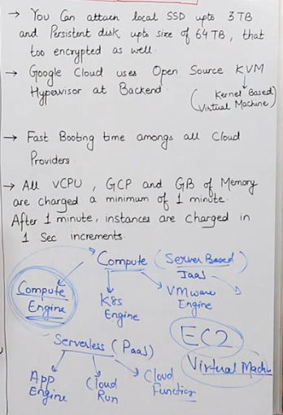

Virtual Machine is called Compute Engine in GCP, EC2 (Elastic Compute Cloud) Instance in AWS and Virtual Machine in Azure

Ss 7:14 Types of Machine

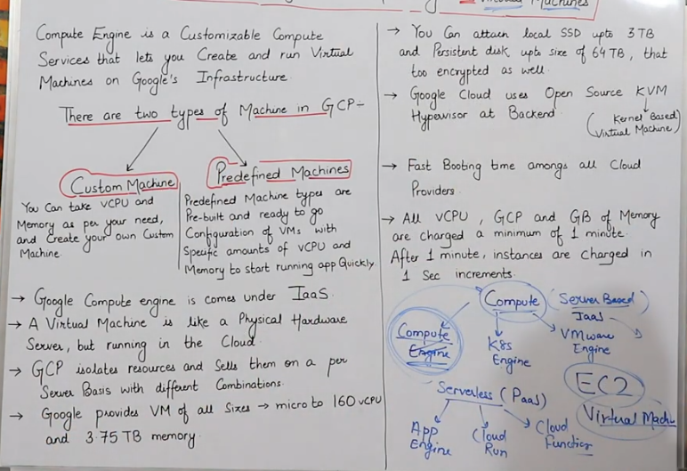

*Google is the only cloud provider that provides Custom Machine.

* Local SSD in Google is a temporary storage provided in a server. It is same as Ephemeral Disk in Azure and Instance Store in AWS. Here, only temporary data can be store as the data gets deleted if the VM is stopped or restarted. Local SSD can be used for fast processing of data (benefit). Local SSD is also called DAS and MAS as it is a part of the hardware and directly connected to it.

DAS - direct attached storage

MAS - machine attached storage

*We cannot install operating system In local SSD. We install operating system in the persistent disc.

*Google cloud keeps all the data and storage by default in encrypted form. AWS and Azure also provide encryption by there we have to select it manually.

*Google uses Open Source KVM hypervisor (kernel based and linux based). AWS uses Nitro.

Azure uses Hyper V which is its own hypervisor.

*Google cloud has fast booting time among all cloud providers and least latency.

Ss

Ss 35:20

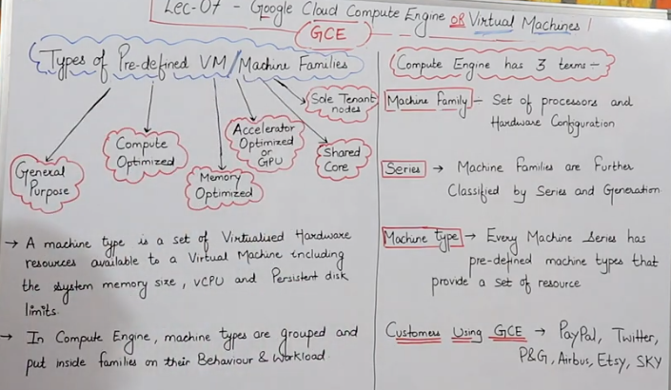

Ss 39:22

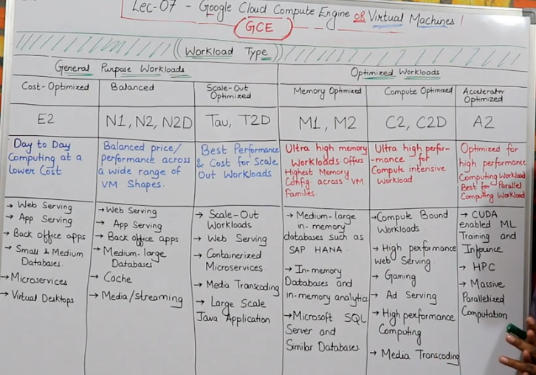

Ss 49:56 & 52:54

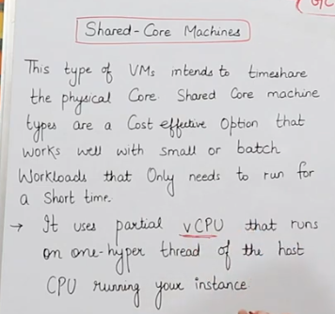 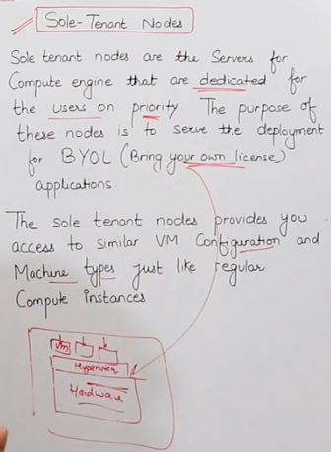

Ss 59:40 & 1:00:20

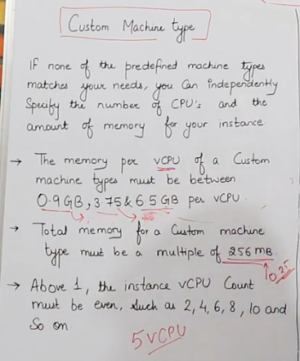 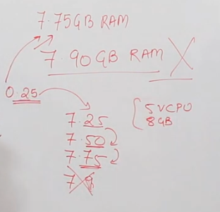

Lec 8 - Ss 6:03 & Ss 8:21 types of discount

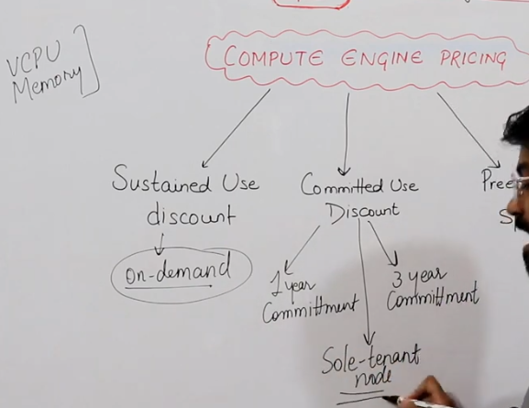 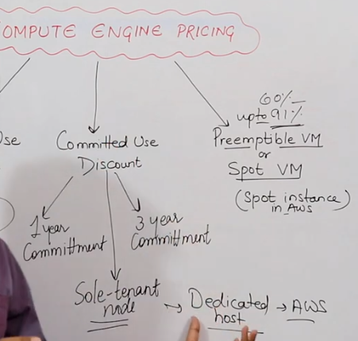

Ss 17:56 Sustained use discount

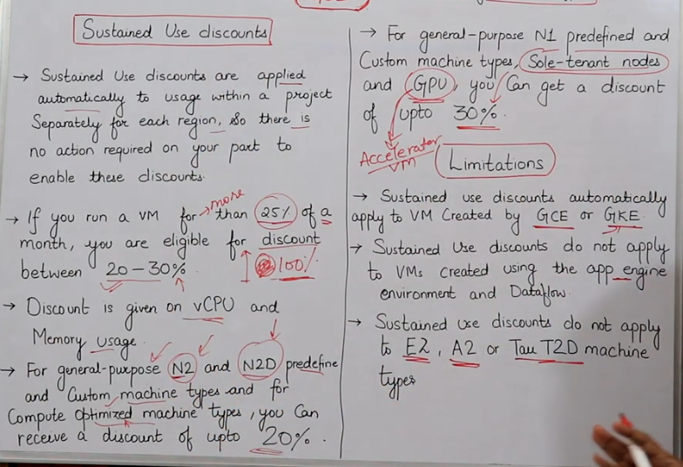

*Sustained use discount is only provided by Google among all other cloud providers to attract customers

Ss 25:18 & Ss 27:56 committed use discount

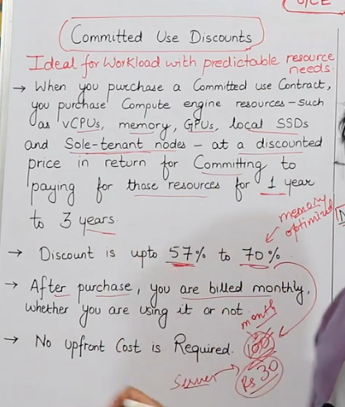 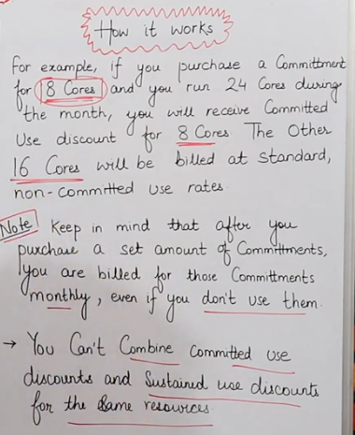

Ss 30:14 & 30:47 limitations

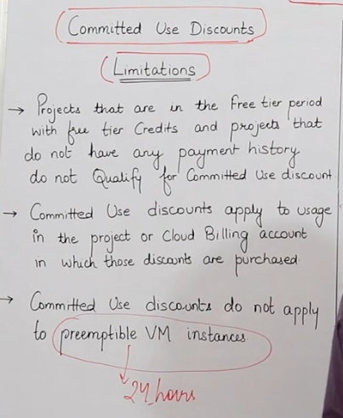 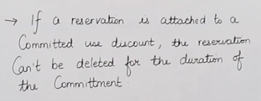

Ss 40:14 & 42:14 Premptible resources

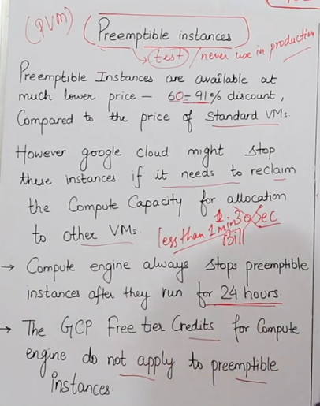 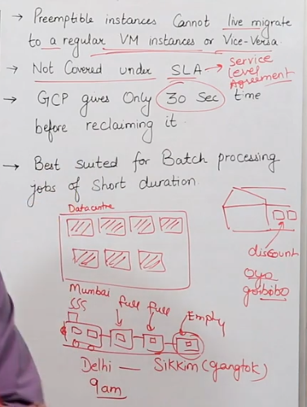

Ss 44:05 storage options

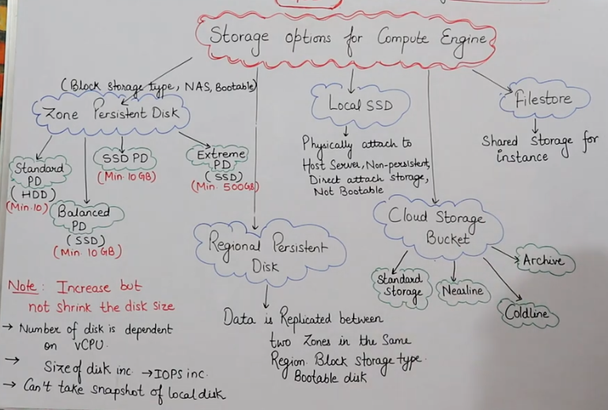

Regional has same disk types as Zonal Persistent Disk.

The four disk types in both Zonal & Regional Persistent Disk are bootable i.e. O. S. Of the server can be run here. The other storages like Local SSD, Cloud Storage Bucket and Filestore are non-bootable.

Local disk is non-persistent i.e. data stored gets deleted when the server is stopped.

Cloud Storage Bucket and Filestore are persistent.

* GCP - Local SSD

AWS - Instance Store

Azure - Temporary or Ephemeral Disk

* Local SSD in Google is a temporary storage provided in a server. It is same as Ephemeral Disk in Azure and Instance Store in AWS

Zonal & Regional Persistent Disk are block storage. Here files are stored by breaking them into equal size of blocks.

Cloud Storage Bucket is an Object storage where files are not broken and as it is stored in the form of objects.

Block storage is faster than Object storage and can be used as a bootable disk

IOPS is input output per second

A persistent disk is connected to a zone or a region through network. Thus even if one VM in that zone or region is deleted, then that disk can still be connected to the other new VM. In persistent disk the data doesn't get deleted after a server is stopped or deleted.

Lec 9 - [console.cloud.google.com](http://console.cloud.google.com)

On Main page, go to Dashboard

On clicking Menu, we get all the services provided by GCP

On page header, we have Home button, Project name Displayed and Search bar, free trial status, Activate Cloud Shell, Notifications, Support, Settings and Profile/Account.

Then we have Dashboard, Activity (eg. VM creation, VM deletion etc), Recommendations (provided by GCP based on your usage of services) and Customize (to Customize your Dashboard).

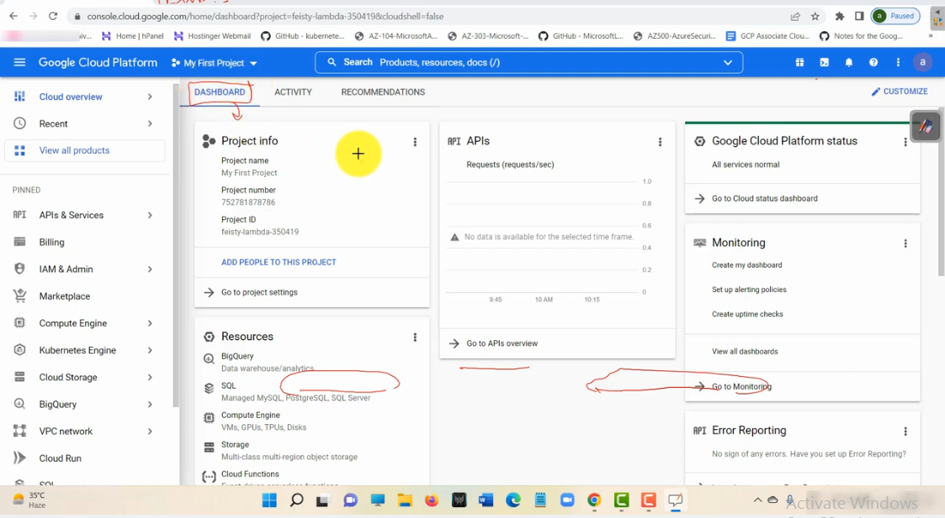

**Gcp lec 10** – Creating a VM in GCP, Ss 1:14, steps to create vm.

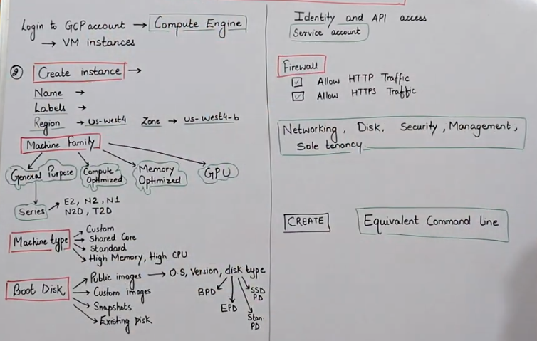

* In AWS we call EC2, in Azure we call VM, in GCP we call VM instance.

In compute engine there are multiple options/services and one of the options is Virtual Machine and inside this also there is an option of VM instance. Ss 14:40 & 15:36

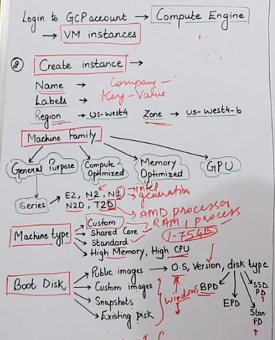 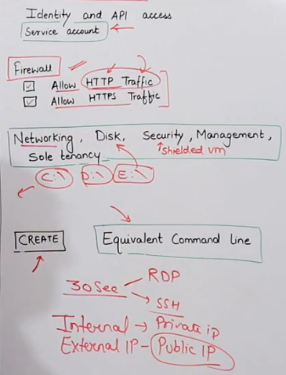

If we do not allow Firewall Http and Https options, then you will not be able to send or receive any requests from internet.

To change the VPC network of the machine or to create a machine on your own network, you can go to Networking.

To add more or multiple disks such as D:\, E:\, F:\ etc on your machine you can go to Disks.

To have a shielded VM (VM with extra security so that no one can easily connect with the VM without our permission as many ports are disabled here), we can go to Security. This option is not available for every VM type.

We click on Create and VM gets created in 30 secs. If we have created a Windows VM then we will take the RDP and if we have created a Linux VM then we will take the SSH of that machine.

*In google cloud, by default we only have a CLI interface. We have to select a Desktop Experience O. S. If we want to see that OS in GUI.

Then, we will download IIS i.e. internet information page and if it works then it will indicate that the firewall settings are working properly. Then we will use the Public ip address on browser and we will be able to see a web page (this will be possible as we had allow firewall http proxy).

**Project Lab:**

GCP Console -> Compute -> Compute Engine -> click **Enable** (we can also explore try API) (this is not chargeable) -> VM Instances -> Create Instance -> Enter name and add labels -> Machine Configuration -> select Machine Family -> select the Series, Machine Type, CPU platform (generally we select automatic), Boot Disk -> Identity and API access -> select Access scopes (select allow default access), Firewall (select both Http and Https) -> Select Equivalent Command Line and copy the command, then select Activate Cloud Shell (on top right of window) and paste the command here Or select Run in Command Line and enter, then Authorize Cloud Shell OR select CREATE -> VM gets created -> (If Windows OS) select dropdown besides RDP and set windows password -> click on RDP and click on link to Download, open downloaded file, click Connect, enter password, yes and windows machine gets started.

Right click on options to Delete your VM

* In GCP, if you want to use any service, then it will ask you to firstly enable the API for it.

The price of a VM majorly depends upon the number of VCPUs, memory of VM, O. S. Lisence, storage disk size and region. We should not choose the region which is less expensive. Rather we should always select the region where most of the users of the application will be using it.

Once a VM is created then the zone or the region of that VM cannot be changed.

Also, if a VM stops working due to some fault in the background, the Google cloud will create a new machine as a replacement for it in the same zone.

In Machine Series, digital 1 or 2 denote the general, D denotes AMD processor, if D is not present then it denotes Intel processor. You can add external IP address (Public)

**Lec 11 :** Install Apache on GCP Linux, Ss 7:42 & 14:17

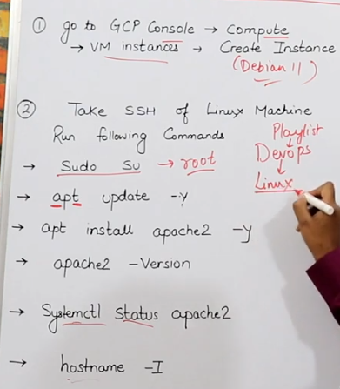 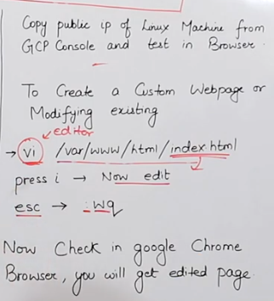

**Project Lab:**

GCP Console -> Compute -> Compute Engine -> click Enable -> VM Instances -> Create Instance -> Enter name and add labels -> select Region and Zone -> Machine Configuration -> select Machine Family -> select the Series, Machine Type, CPU platform (generally we select automatic), Boot Disk -> Identity and API access -> select Access scopes (select allow default access), Firewall (select both Http and Https) -> Select Equivalent Command Line and copy the command, then select Activate Cloud Shell (on top right of window) and paste the command here Or select Run in Command Line and enter, then Authorize Cloud Shell OR select CREATE -> VM gets created -> (If Windows OS) select dropdown besides RDP and set windows password -> click on RDP and click on link to Download, open downloaded file, click Connect, enter password, yes and windows machine gets started.

**Lec 12:** Create and manage VM instances using CloudShell, Ss 00:36

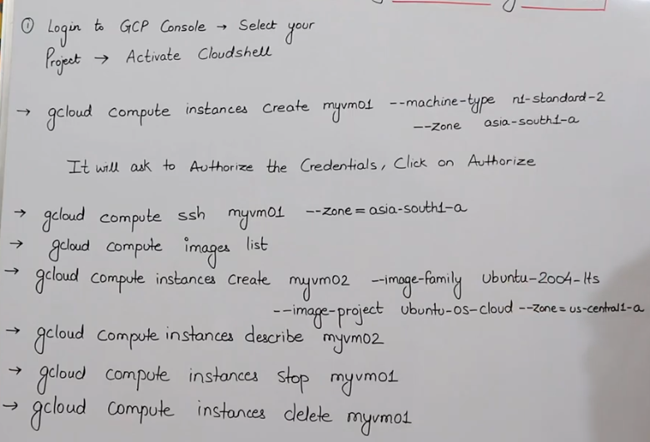

Every command in GCP starts with keyword “gcloud”.

# Here “myvm01” is the VM Name. GCP will take all the other specifications such as OS, machine configurations, firewall settings etc by default when we do not specify them in the command shell. It will by default take Linux as OS.

# Type ‘exit’ to come out of VM.

# All the above mentioned commands need to be run on the Cloud Shell and not inside the VM.

# Command 1 : to create a VM “myvm01” (or instance) based on machine type ( we have to declare anything using a double dash “--“)

# Command 2 : to take ssh of your Linux machine

# Command 3 : to get list of images

// To create a VM from any one of the list of images, we need the image-family and the image-project

# Command 4 : to create another VM “myvm02” based on an image.

# Command 5 : to get complete details of VM “myvm02”

# Command 6 : to “stop” VM (here we can also use “start” or “restart” keywords to start or restart the VM)

# Command 7 : to “delete” VM

**Project Lab:**

# In the Lab, we created a VM using the Command 1. Inside the VM, we used below commands:

help

ls -a

touch file1 file2 file 3

vi file1

cat file1

sudo su

apt update –y

apt install apache2 –y

sudo systemctl status apache2

# Then, we copy external IP of VM and paste on browser //Webpage will not load as port 80 & firewall is not enabled

# Then, we come out of the VM and run all the other Commands including start command.

# gcloud compute instances list //to get the list of all the machines

# If multiple machines created are under the same zone, then those multiple machines can be deleted at the same time with a single command :- gcloud compute instances delete myvm01 myvm02.

**Lec 13:** Changing Machine Type of VM, Ss 1:44

# Here, we are doing Vertical Scaling (moving from a smaller to a larger server or slower to faster server).

# In Cloud, auto-scaling is always done Horizontally. The scaling that is done manually is always Vertical Scaling.

# To upgrade a server, it is mandatory to stop that server.

# If your VM has local SSD, make sure to take a backup of your data before upgrading the server (as local SSD data will get lost).

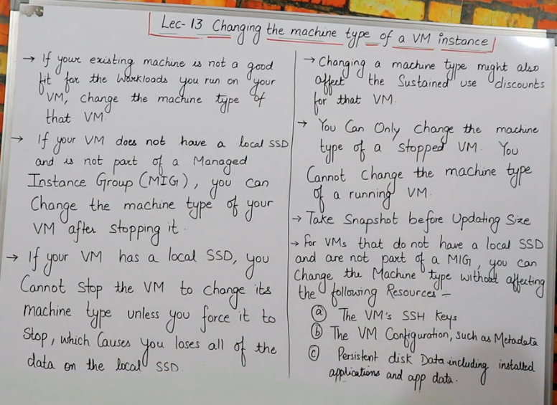

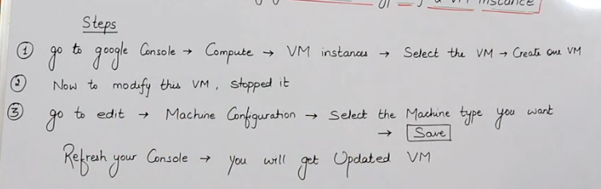 Ss 18:08

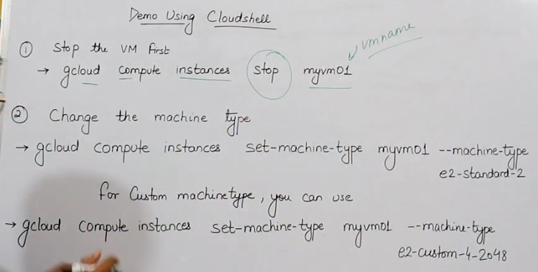 Ss 28:40

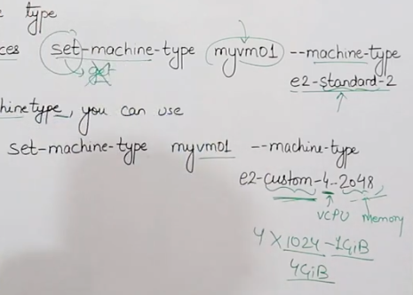 Ss 34:28

# We can also downgrade our VM in Cloud (but there are chances that data might get corrupt).

**Lec 14:** Resize Persistent Disk of VM, Ss 14:15

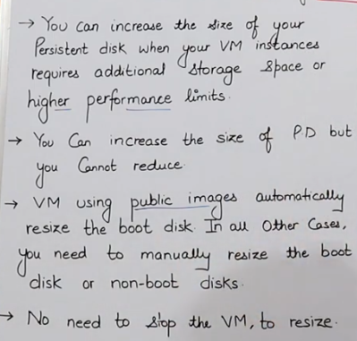

# Boot Volume is a normal storage but it contains the O.S. and thus it is known as “Boot Volume”. (In Windows, C Drive is the Boot Drive)

* In GCP it is called Persistent Disk, In AWS it is called Amazon Elastic Block Store (Amazon EBS), In Azure it is called Managed Disks.

Persistent Disk is a storage whose data does not get deleted by stopping or terminating or restarting the server.

# In GCP, the more the storage, the more will be IOPS.

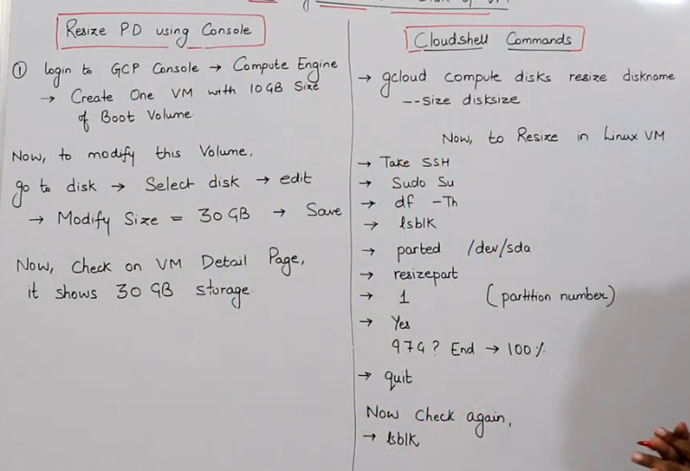

Here, we can view diskname for shell command from Console. Here, disksize to be mentioned in terms of GB.

# In the above CloudShell Command, need to mention the zone or the region as well for the command to work.

Now, after we resize the disk on the Cloud, it will not reflect the changes into the server. So, we have to take above steps.

# df –Th //It will show all the partitions i.e. all the boot and non-boot volume partitions.

# lsblk // It will show the logical blocks of all the partitions

# parted /dev/sda // parted means resize. Here we want to resize the sda storage (boot volume that has been resized on the Cloud) of the device.

# Fix //enter this when question asked - Do you want to fix/ignore ?

# 1 //partition no.

# Yes

# 110% // Enter this

# quit // when you see message (parted)

//Now, it will show Updated Size

(All the above Steps are for a Linux server)

* Steps to Resize Disk for a Windows Server :

# Create a Windows VM of Disk size 50GB and then change it to 100GB from Console -> Disks.

# Then inside it in Console click on ‘Set Windows Password’ and copy the pwd generated.

# Then take RDP, open the RDP file and enter pwd.

# Then inside the Windows VM, goto Windows -> Server Manager -> Files and Storage Services -> Volumes (Here you will see 50GB)

# Then goto Windows -> Disk Management -> Action -> click Refresh (Now, you will see 99.98GB under Disk0.

# To move this storage to Disk C, right click on ‘Disk C 49.89GB’ at bottom of same page -> click Extend Volume -> Next -> Next -> Finish

//Now, it will show Updated Size

**Lec 15:** Types of Images Ss 16:01

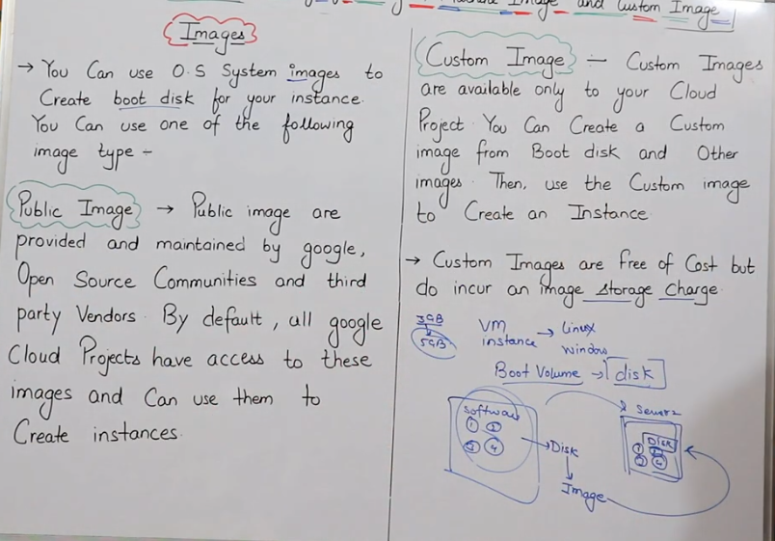

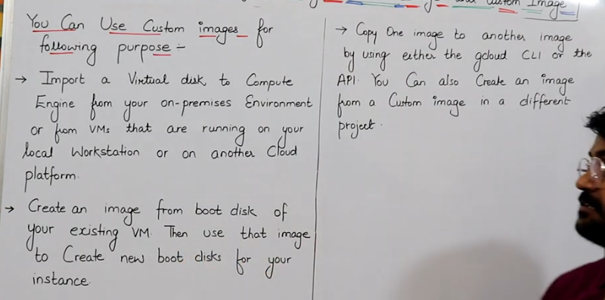 Ss16:41

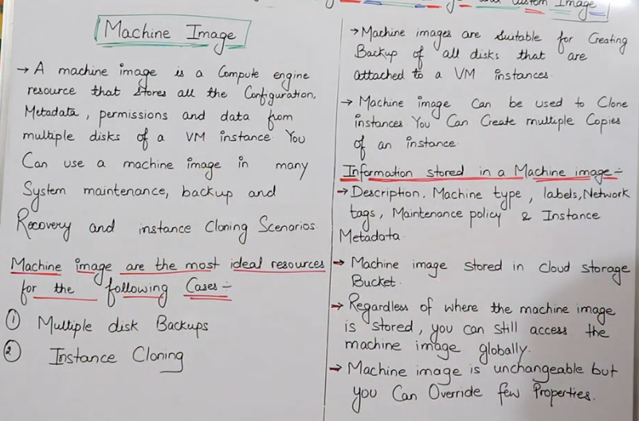 Ss 24:08

# In AWS, Machine Images are stored in S3 Buckets and In Azure Machine Images are stored in Azure Blob Storage.

# When a Server is created from Machine Image, we can change the configurations at the time of Server Creation.

# Machine Image cannot be modified.

# Below is the Workflow of Creating a Bootable Disk.

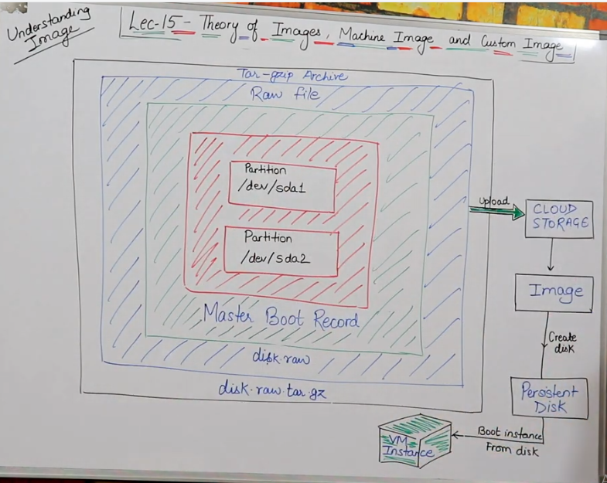 Ss 33:10

# In a Server, we have multiple storages, in Windows we have C and D Drive, In Linux we have sda1 and sda2 etc. When we create Image of these Disks, it will be called Master Boot Record. Then a raw file of the Master Boot Record is created called “disk.raw”. Then this disk.raw file is done tar.gzip (.tar means archiving data means collecting/zipping of multiple files and gzip is used to compress files to decrease their size). Then the disk.raw.tar.gzip file is uploaded on the Cloud Storage. Then an Image is created and stored in the Cloud Storage. Now, we can create a Disk/Persistent Disk from the Image. Now, this Persistent Disk will be used when a VM Instance is created and we will get all the data and Configurations of the Disk from the Image that we had selected (which was created/copied previously from a Server).

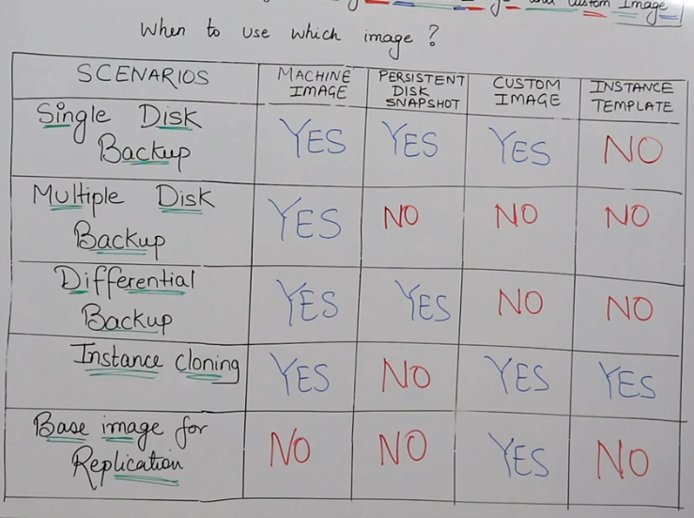 Ss 40:26

# Using Persistent Disk Snapshot, we can take Snapshot of Disk to take backup of the Data.

# In Instance Template, we can create a Template of our Server.

# Differential Backup means taking the Backup of only the changes that were done during the Last Change, all the Backup of other previous Changes is already being stored differentially the similar way.

# Base Image contains O.S.

**Lec 16:** Creating Custom Images & VM

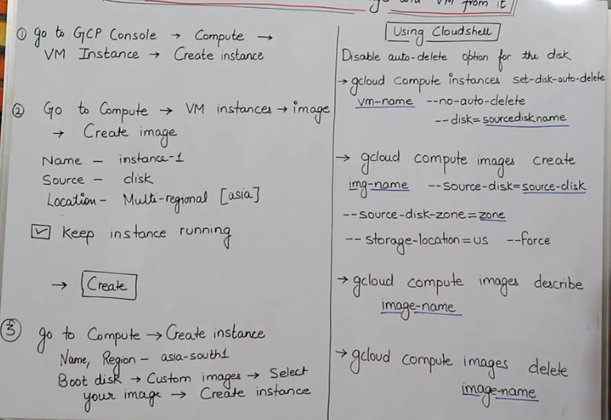 Ss 00:29

# After Step 1, Inside the VM, create some files(touch file1 file2), install a Web Server (apt update –y; apt install apache2 –y; systemctl status apache2) and create a Webpage (vi var/www/html/index.html (here update something)).

# In place of sourcediskname, you can enter the name of the disk that you want to keep.

# img-name is name of the image.

# In command 2 under CloudShell, the actual words are “--source-disk= source-disk-name”.

# Here against the source-disk-zone, we need to mention the Zone where the existing Disk is present.

# Here against the storage-location, we need to mention the location where we want the new image to be created.

# --force means Keep Instance running.

# Firewall should be On i.e. allow HTTP & HTTPS Traffic (to allow requests coming from Internet) if we want to run a Webpage hosted on our Server.

# After doing the Lab, Delete the Disks and the Images created.

**Lec 17:** Creating Machine Image from VM, Ss 00:44

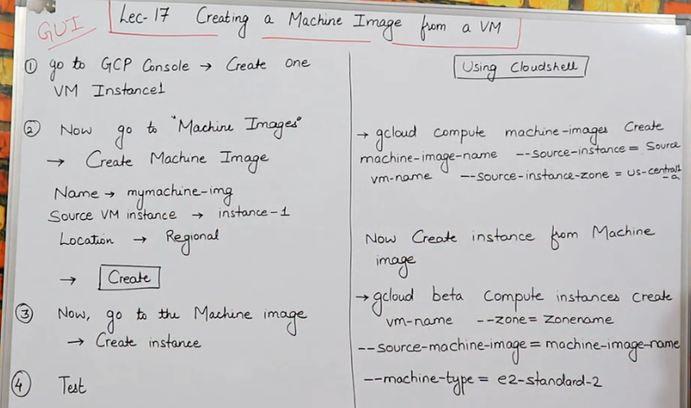

# After GUI Step1, we will have Debian O.S. Server which will by default have 10 GB Disk Storage. Then additionally, we will take 20GB storage (In Console -> Create Instance-> Advanced Options -> Disks-> Add New Disk-> Disk Source Type-Blank Disk, mention Size) Then, Inside the VM, create some files(touch file1 file2), install a Web Server (apt update –y; apt install apache2 –y; systemctl status apache2) and create a Webpage (vi var/www/html/index.html). Then type lsblk and we will be able to see two storages sda 10GB and sdb 20GB.

# In CLI Command2, writing machine-type is not necessary if we are keeping the machine-type of the new Instance same as the machine-type of the machine-image, but we can mention machine-type if we need to create the new Instance with a different machine-type.

**Lec 18:** Cloud Storage & Types,

Storage Types/Options in GCP, Ss 06:07

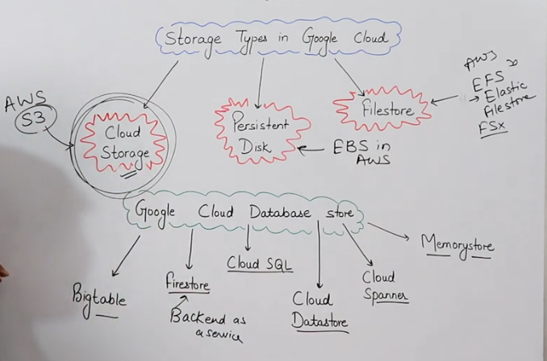

Cloud Storage, Ss

# We cannot install O.S. on Cloud Storage

# Container mentioned here is just a Box or Folder and has no similarity with Docker or related Containers.

Ss 10:33 & 26:32

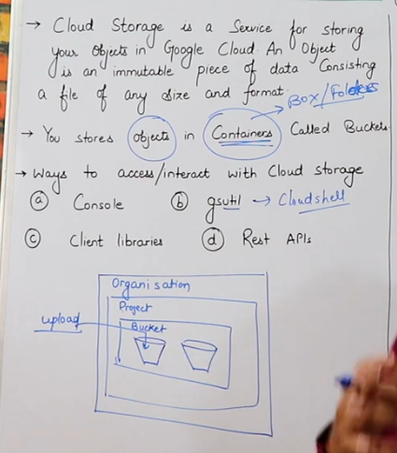 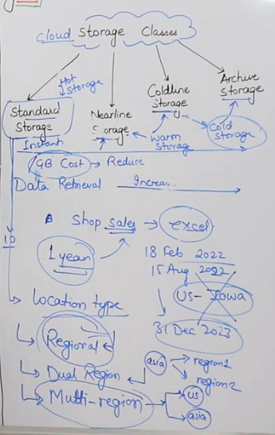

**Lec 19:** GCPCloud Storage Types Ss 6:17 & 7:37

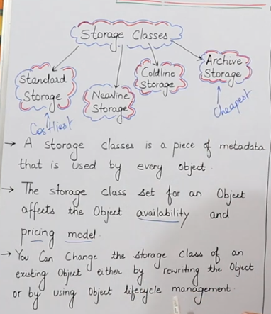 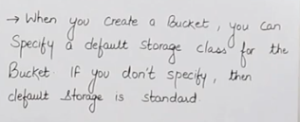

Ss 12:48 & 16:26

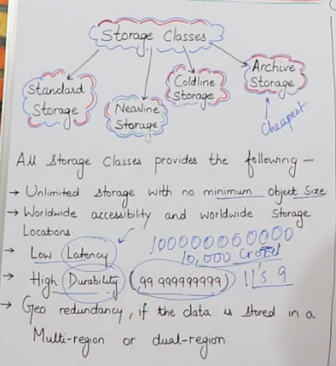 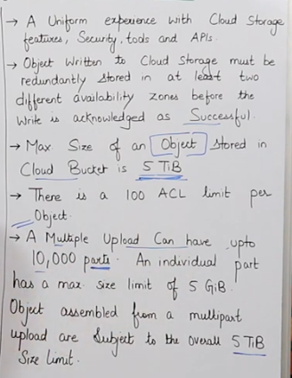

# What is the maximum storage that a Bucket can store ? -> It can store Unlimited Data

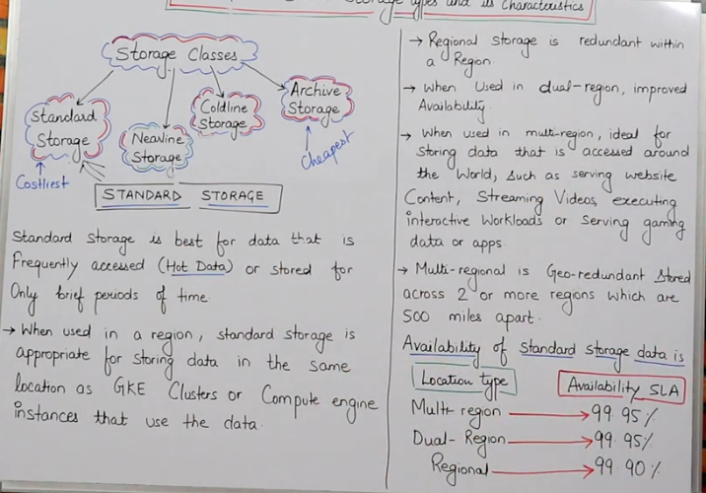 Ss17:20

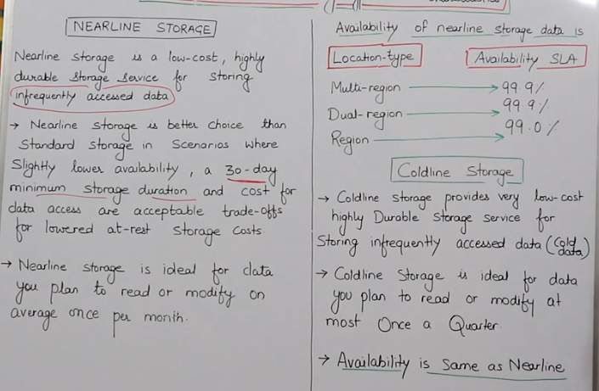 Ss 27:07

# In Nearline, Coldline or Archive Storage, if we are accessing data very frequently like everyday, then the Cost will exceed Standard Storage because here the cost of storage is very low but the cost of accessing data is very high. So, think wisely while choosing the storage type.

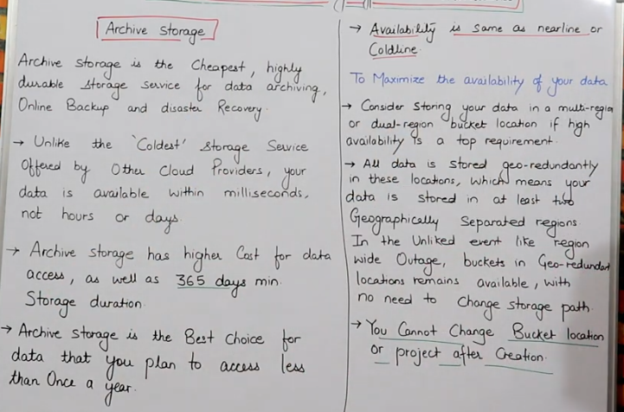 Ss 30:17

**Lec 20:** GCPStorage Pricing, Buckets & Objects Ss 04:37 & 10:33

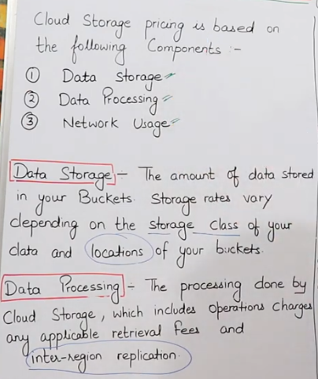 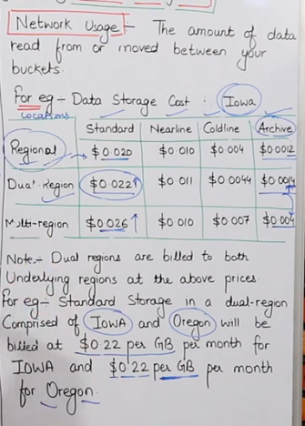

# Multi-regions are also billed for each of the associated regions.

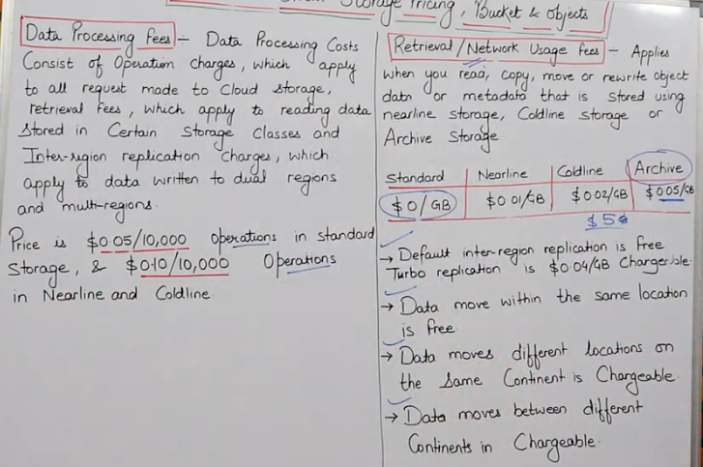 Ss 15:35

# Data moving between buckets in the same location is free.

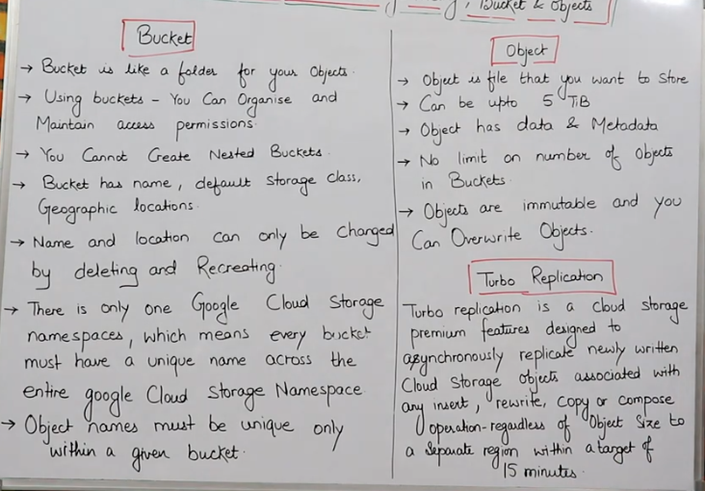 Ss 18:50

# In Cloud, when we have to store anything we cannot store it directly and we have to create a Bucket to store the data.

# Cloud Storage is an Object Storage.

# Objects are immutable means Objects cannot be modified inside a Bucket. You can modify/update your data in your personal system and then again upload the updated data i.e. you can overwrite objects.

**Lec 21:** GCPStorage Complete Demo

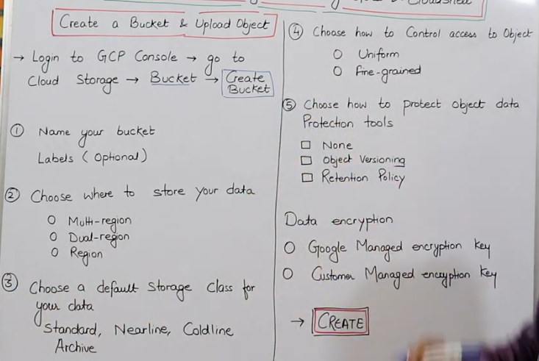 Ss 2:43

# In Bucket name, no Capital Letter, ‘.’ Or ‘-‘ should be entered. IP Address should not be entered as a Bucket name. Letters ‘google’ or similar letters should not be entered as a Bucket name. (You can refer Naming Guidelines in the GUI).

# Uniform means same rules for all the Objects in the Bucket & fine grained means different rules for different objects.

# Object Versioning is similar to code versioning done using git.

# Retention Policy means setting the duration till which the data will be protected and not get deleted.

# In Lab, If you want to add a Permissions to your Bucket then, Console -> Storage -> Cloud Storage -> Buckets -> click on the created Bucket Name -> Permissions -> (at bottom of page near Permissions) click Add -> New Principals – allUsers -> Role – under Cloud Storage select ‘StorageObject Viewer’ -> Save -> Allow Public Access.

After this, a Public Url will be generated against your Objects and any user with that Url will have access to view your Objects inside the Bucket.

# We can turn Object Versioning On by going to, Console -> Storage -> Cloud Storage -> Buckets -> click on the created Bucket Name -> Protection -> Click on Object Versioning Off and Confirm.

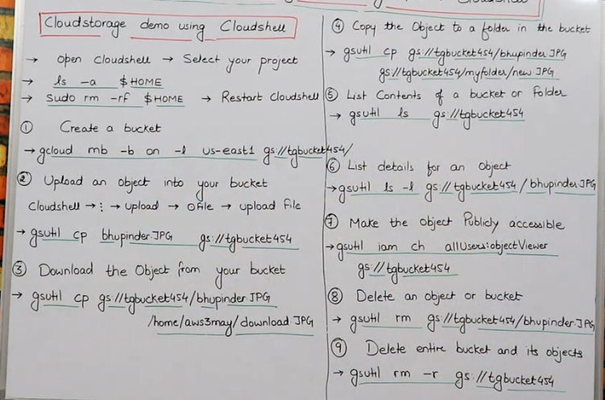 Ss 25:53

# sudo rm –rf $HOME //This will remove all the files forcefully from the server.

# Before Command(1), restart Cloudshell & select ‘Want Clean VM State’

# gsutil (Google Storage Utility) is a common command that is used for Google Storage.

# In Command (1), In gcloud mb, mb means make bucket, -b means working inside bucket, -l means location, gs means Google Storage.

# If we want to upload an object on our Bucket, then firstly we need to have that object on the Cloud Shell Machine.

# Before running Command(3), run pwd and copy the path. Then in Command(3) replace the /home/aws3may/ with this path. Here download.JPG is the name that you can provide to save the file. After running Command(3), do ls to see the file.

# In Command (7), iam ch means changing the IAM Policies.

# In Command (7), to reverse the changes that we have doen then we can write the command :- gsutil iam ch –d allUsers:objectViewer gs://tgbucket454

# In Command(9), -r means recursive.

**Lec 22:** Object Versioning & Bucket Lifecycle Ss 7:43

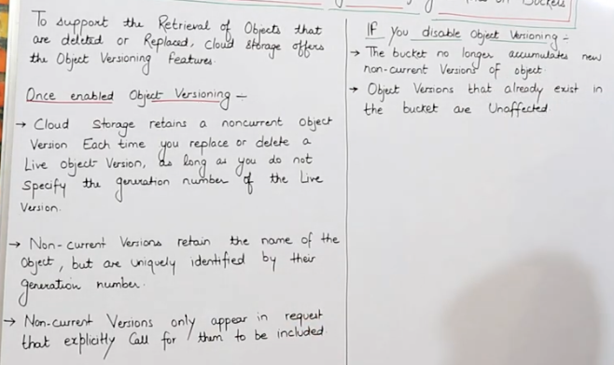

# (P2)Here, retains means makes the deleted Live Object as a Noncurrent Object.

# (P4)Noncurrent versions will only appear if we call them explicitly.

# Lab:- # We can turn Object Versioning On by going to, Console -> Storage -> Cloud Storage -> Buckets -> click on the created Bucket Name -> Protection -> Click on Object Versioning Off and Confirm.

# To View the Version History of the Object we goto, Console -> Storage -> Cloud Storage -> Buckets -> click on the created Bucket Name -> Objects -> Click on Object Name -> Version History -> Now we can view any Object Version

# To Delete a Live Object we goto, Console -> Storage -> Cloud Storage -> Buckets -> click on the created Bucket Name -> Objects -> Click on Object Name -> Live Object -> Delete

# To make any Noncurrent object a Live Object we goto, Console -> Storage -> Cloud Storage -> Buckets -> click on the created Bucket Name -> Objects -> Click on Object Name -> Version History -> Against the Object Version click Restore

# If we delete any Noncurrent object, we cannot recover it.

Steps to do Object Versioning using Cloud Shell :

1. Goto Console -> Activate Cloud Shell
2. ls -a $HOME
3. sudo rm –rf $HOME
4. ls
5. Restart Cloud Shell
6. Do Object Versioning Off in Console (if already On). In Console, you can do this with command :- gsutil versioning set off gs://bucket76767

Here ‘bucket76767’ is the Bucket Name.

1. To On the Object Versioning, use command :- gsutil versioning set on gs://bucket76767
2. To check if Object Versioning is enabled or not, use command :- gsutil versioning get gs://bucket76767
3. To see all the current & non- current versions of objects in a Bucket, use command :- gsutil ls -a gs://bucket76767

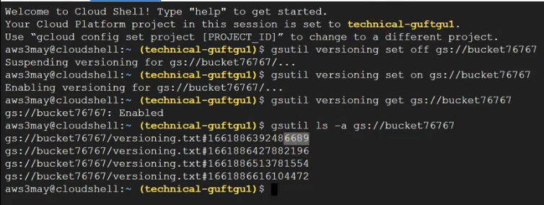

# Here, it will show the oldest version of the object at the first line & latest version at the last line.

1. To make a non- current file as a live file :- gsutil cp gs://bucket76767/versioning.txt#1661____6689 gs://bucket76767/ versioning.txt (means gsutil copy source to destination)



1. To delete an Object Version, use command :- gsutil rm gs://bucket76767/versioning.txt#1661____6689

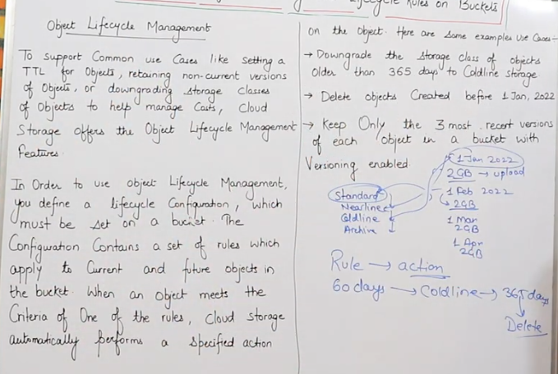 Ss 35:51

# TTL means Time To Leave.

# Any actions on the Policy rules created can take upto 24 hrs to take place, Eg: if a rule has been created that needs to take action on a particular date then it will not take place exactly at 00:00 or immediately once the criteria is met.

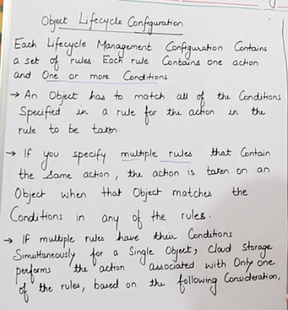 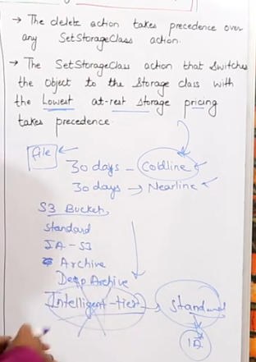 Ss 43:09 & 46:09

# Amazon has Intelligent Tier Storage type that takes decision by itself to move data to storages with time as per the usage pattern of the User.

Object Lifecycle Management in Console :

# Console -> Storage -> Cloud Storage -> Buckets -> click on the created Bucket Name -> Lifecycle -> click ‘Add a Rule’ -> Then firstly select an action (only one option can be selected here)

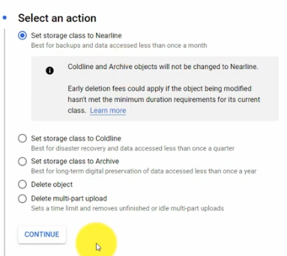

-> Then, click Continue -> Now Select Object Condition (multiple options can be selected here)

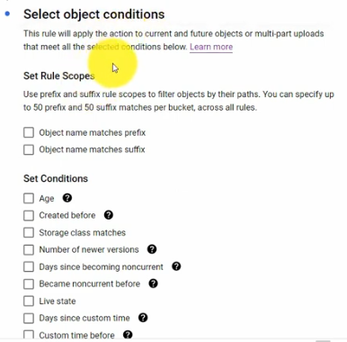 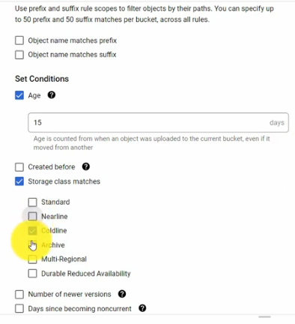 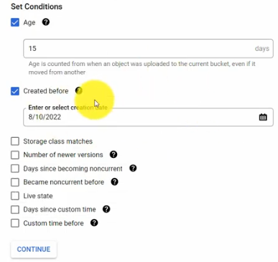

-> Then, click Continue -> Then, click Create. Lifecycle Rule will get created.

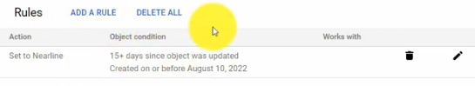

# We can Add more Rules or Delete Rules from the Console.

Object Lifecycle Management using Cloud Shell :

# Doing this through Cloud Shell is bit complex. Goto its documentation by searching “Object Lifecycle Management” in searchbox on the Console. Goto this Link <https://cloud.google.com/storage/docs/managing-lifecycles#command-line> .

# To Set the lifecycle configuration for a bucket

1. Create a JSON file with the [lifecycle configuration rules](https://cloud.google.com/storage/docs/lifecycle#configuration) you would like to apply. See [configuration examples](https://cloud.google.com/storage/docs/lifecycle-configurations) for sample JSON files.
2. Use the [gcloud storage buckets update](https://cloud.google.com/sdk/gcloud/reference/storage/buckets/update) command with the --lifecycle-file flag:

gcloud storage buckets update gs://*BUCKET_NAME* --lifecycle-file=*LIFECYCLE_CONFIG_FILE*

Where:

* *BUCKET_NAME* is the name of the relevant bucket. For example, my-bucket.
* *LIFECYCLE_CONFIG_FILE* is the path for the JSON file that you created in Step 1.

# See configuration examples for sample JSON files :- Delete older object version

The following lifecycle configuration defines two rules. Note that these rules are applicable only when [using Object Versioning](https://cloud.google.com/storage/docs/using-object-versioning#set) on the bucket:

1. Delete noncurrent versions of objects if there are 2 newer versions of the object in the bucket. Objects subject to this rule are permanently deleted and cannot be recovered.
2. Delete noncurrent versions of objects after they've been noncurrent for 7 days. Objects subject to this rule are permanently deleted and cannot be recovered.

The combined effect of these two rules in buckets that use Object Versioning is that live objects have a window of time in which they can be [recovered](https://cloud.google.com/storage/docs/using-versioned-objects#restore) if they get overwritten or deleted: such an object remains in the bucket in a noncurrent state for seven days or until 2 newer versions of the object exist in the bucket.

The following lifecycle configuration can be applied to a bucket by [enabling lifecycle management](https://cloud.google.com/storage/docs/managing-lifecycles#set).

{

"lifecycle": {

"rule": [

{

"action": {"type": "Delete"},

"condition": {

"numNewerVersions": 2,

"isLive": false

}

},

{

"action": {"type": "Delete"},

"condition": {

"daysSinceNoncurrentTime": 7

}

}

]

}

}

For the generalized format of a lifecycle configuration file, see the [bucket resource representation for JSON](https://cloud.google.com/storage/docs/json_api/v1/buckets#resource-representations).

# Copy this above JSON file into a notepad file in your personal System & save as Rule1.json (& select All Files Option)

# Now upload this File into your cloud shell machine

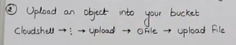

# Now run the CLI command provided above.



# Now, applying another rule using CLI. (Refer <https://cloud.google.com/storage/docs/lifecycle-configurations> )

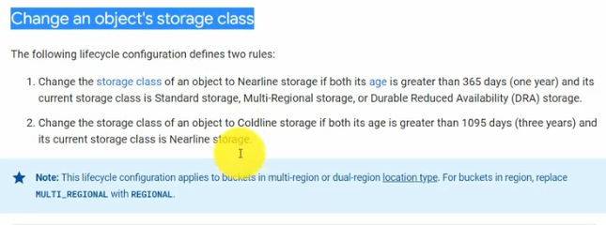

# Now, copy the below & save in rule2.json file in your personal System & then upload this File into your cloud shell machine.

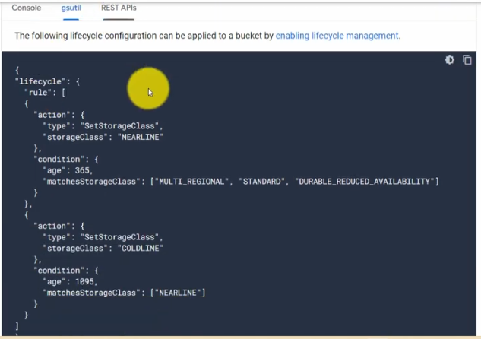

# Now run the CLI command as below :



# Now, we can see that New Rules have been set.

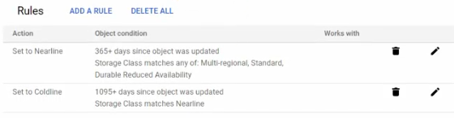

# Now, we check the Lifecycle Versioning of the bucket using command :- gsutil versioning get gs://bucket76767



# To remove the Lifecycle Versioning

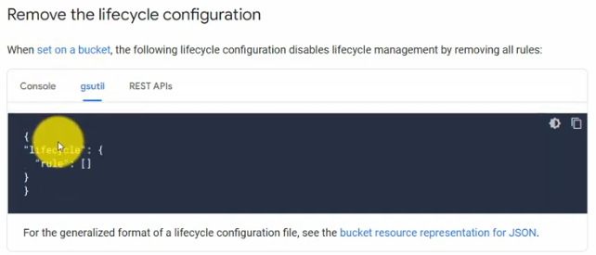

Paste this in delete.json & follow other steps.



**Lec 23:** Signed URL

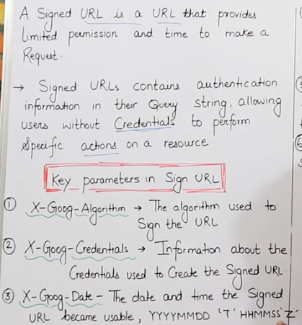 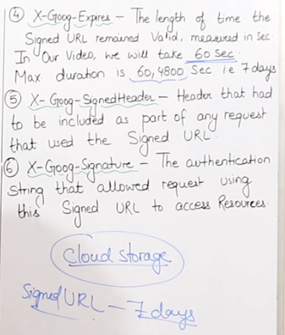 Ss 05:59 & 06:56

# Here, limited permission can be read or write etc.

# Signed URL is used for Cloud Storage and can only be created using Cloud Shell.

Steps to Create a Signed URL :

1. Console -> Storage -> Cloud Storage -> Buckets -> Create a Bucket -> add a File like image.jpg as an Object (Refer to previous lectures)
2. Console -> API & Services -> Credentials -> See at the bottom if you already have an Account under ‘Service Accounts’. If not then click on ‘Create Credentials’ & then on ‘Service Accounts’ & take it as ‘Compute Engine default service account’-> After Created, click on the Account Email to open it -> Goto ‘Keys’ -> click ‘Add Key’ & ‘Create New Key’ -> Select Key Type as JSON -> A file will be downloaded on my System.
3. In CloudShell, do ‘sudo rm –rf $HOME’ & then Restart Cloud Shell
4. Now, upload your Json Key file renamed as key.json into the Cloud Shell.
5. sudo su
6. To create a Url, firstly we would require some Libraries and we will have to install them. Use command :- pip install pyopenssl
7. Now to create a Url, use command :- gsutil signurl -d 60s key.json gs://bucket76767/image.JPG //-d means duration, 60s means 60 seconds & after that Url will expire, then we mention key file name, then we mention the Bucket name followed by the object name.

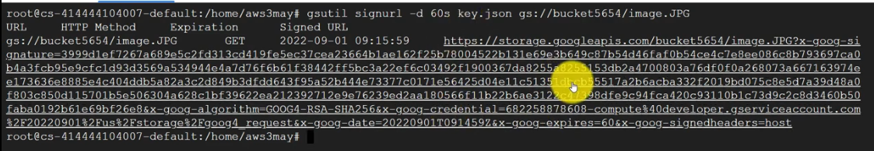

# Here we can see all the Key Parameters of the Signed Url.

# When we open the Url in browser, we see the Object.

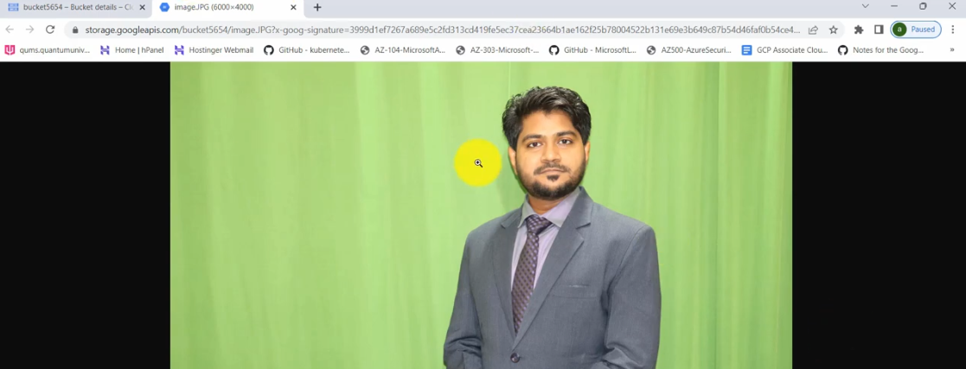

# When the Url expires, we will see an error message.

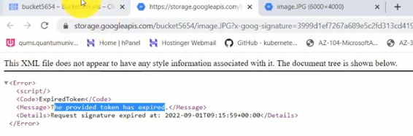

# At the end of Lab, delete the Key, Object & Bucket.

**Lec 24:** Static Website Hosting Ss 03:22

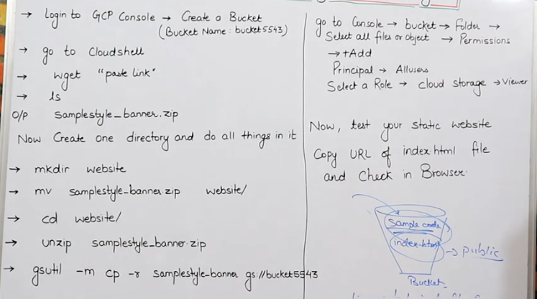

# gsutil –m cp –r (source) (destination) //Here, -m means for multiple files (basically used for multi threading), - r means recursive i.e. do one by one

# We will take sample website code from html5webtemplates.co.uk & download simplestyle_banner

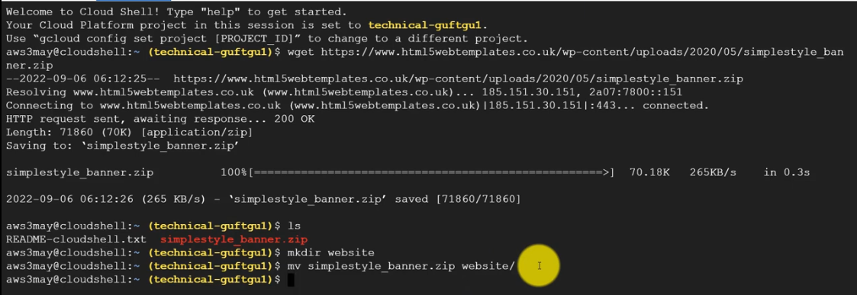

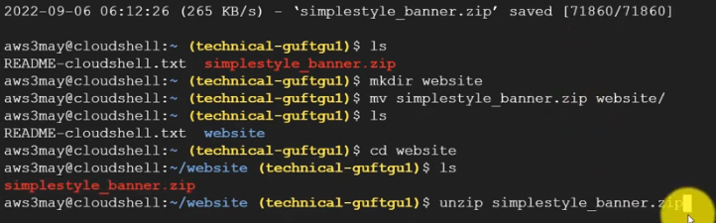

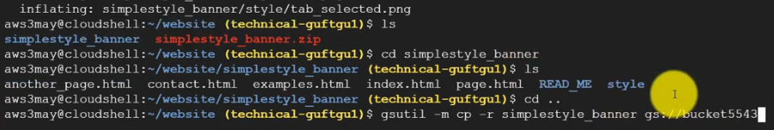

# Now we can see all the files inside our Bucket

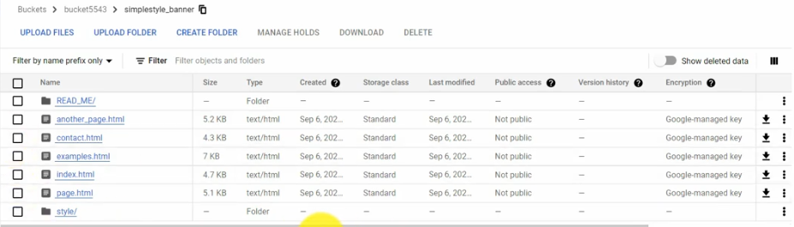

# At this point, if we try to open the website, it will not open properly.

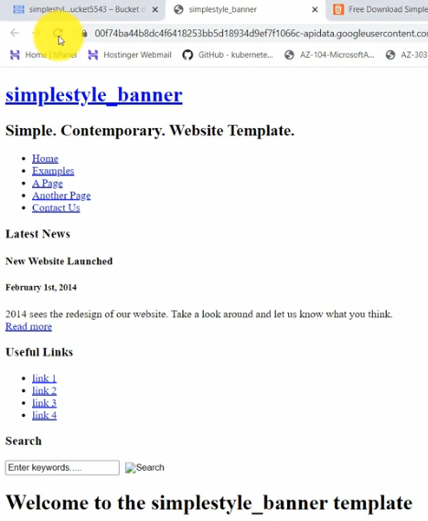

# Now, select all files, goto Permissions -> Add -> Select ‘allUsers’ & ‘Storage Object Viewer’ & Save

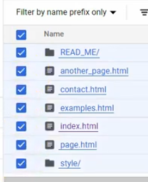 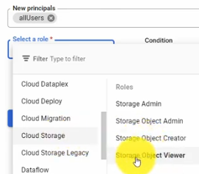

# Refresh Objects & Copy Url again & Open

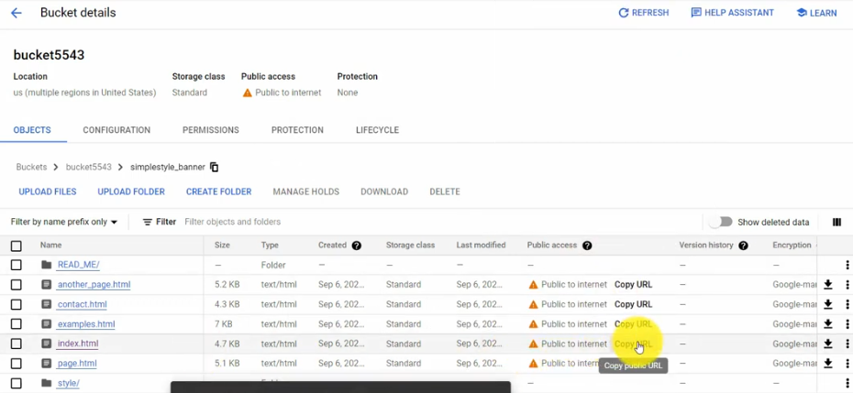

# Now, website will run fine.

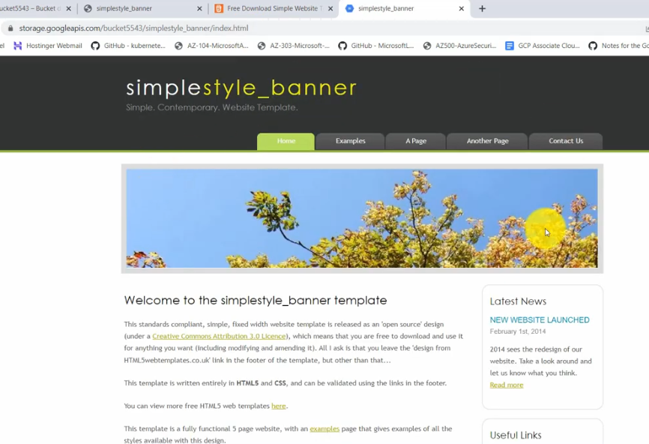

**After Lec 53 :**

I cleared my Associate Cloud Engineer Exam on 2nd July'23 , Many thanks to Bhupinder sir for making these detailed videos which helped me to crack the exam. Would like to add some inputs from myside which can help others to crack this exam as well. Some additional tasks you should do before appearing for exam. 1.Check for K8 video by Ranga as this topics is missing and is a key topic for exam.Its just a 45 mins video. [https://www.youtube.com/watch?v=jW_-KZCjsm0&pp=ygUNazggaW4gNDUgbWlucw%3D%3D](https://www.youtube.com/watch?v=jW_-KZCjsm0) 2.Check below Videos by Satish VJ which will give you an understanding how to approach questions in exam ,give time to these videos its very important. <https://www.youtube.com/watch?v=MESzvFfGhN8&list=PLQMsfKRZZviRwqJwNmh1eAWnRMvlrk40x>3.Practise exams by Udemy.Set of 5 papers.Do it after you complete above points. <https://www.udemy.com/cart/success/938403454/>

Note : These exams are tough but they will prepare you for exam and clear your understanding further. -Even if you dont pass in these tests,reading through the explanation of right answers will clear your understanding further. -Almost 25 to 30 % of exam questions appeared for me in exam as is without any change. 4.Finally TIPS which are very useful <https://www.google.com/search?q=youtube+gcp+exam+tips&rlz=1C1GCEU_en-GBIN969IN969&tbm=vid&sxsrf=AB5stBixtv9UTFUKA-Ds9L7IRZvBRVOt2w:1688392972927&ei=DNWiZOyaOK6r4-EPjI-ngA8&start=20&sa=N&ved=2ahUKEwjs0JH72fL_AhWu1TgGHYzHCfA4ChDy0wN6BAgYEAc&biw=1366&bih=657&dpr=1#fpstate=ive&vld=cid:5b1dcacc,vid:uSMnN4qCOI0>

All the BEST.